SKILLS QUICK START GUIDE
Create a Skill by Uploading a File
QUICK START GOAL
Use this guide during the workshop to upload the provided .md file into the Skills area of the AI tool of your choice .

Before Opening the AI Tool
1. Open the workshop website.
Workshop Website: https://workshopamia2026.github.io/AMIA-KDDM-2026/#schedule
2. Locate and download all five workshop files before opening the AI tool.
We will use these two files throughout the workshop:
- Causal Clinical Reasoning
- LLM as a Judge
The other three files are provided for your convenience and future reference.

Simple Setup
Step 1: Sign in to the AI tool.
Step 2: Go to the Skills page.
Step 3: Choose how you want to create a Skill.
- Upload a file - upload: Causal Clinical Reasoning & LLM as a Judge.
- Work with the Tool to create a Skill
- Edit an existing Skill
- Use a Blank template
- Ask the tool to create a skill from the chat

How to invoke a skill | Best use | Example
Type @ and select the skill | Easiest and most reliable | Type @, choose Causal Clinical Reasoning, then add the task.
Type the skill name directly | When learners know its exact name | @causal-clinical-reasoning Analyze this simulated case release.
Mention the skill in a natural-language request | Works when the skill is clearly named and installed | Use Causal Clinical Reasoning to evaluate this educational case.
Use it automatically | The system may select it when the task clearly matches its purpose | Analyze this simulated case using a mechanism-based differential.

Platform Navigation
Use the screenshots as navigation guides. Interfaces, labels, and available options may vary by account, workspace, and feature rollout.

ChatGPT
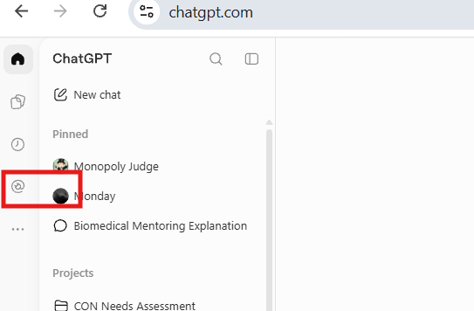  1. Open the relevant menu or workspace area. |   2. Select the indicated control.
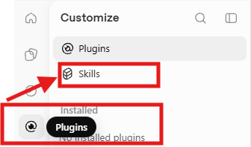
3. Open Skills.
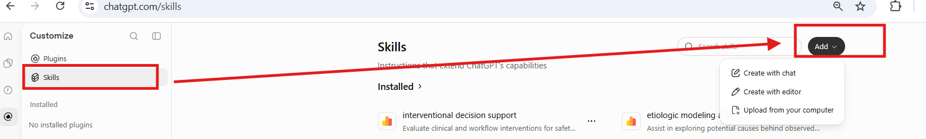
4. Select Add, then choose the available upload or creation option.

Claude
Web navigation: Open https://claude.ai/. Expand the side menu and select Customize > Skills.
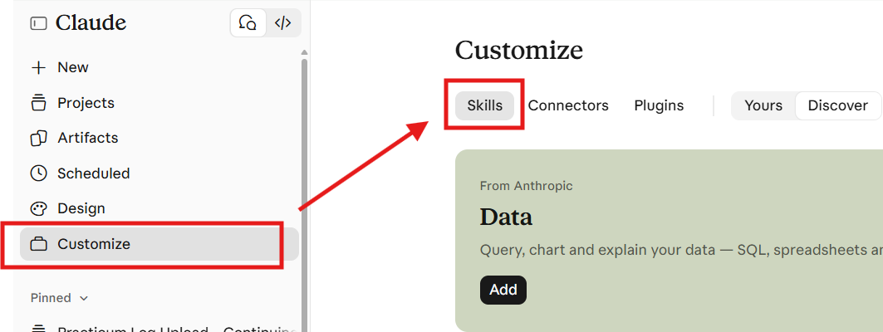
1. Open Customize and select Skills.
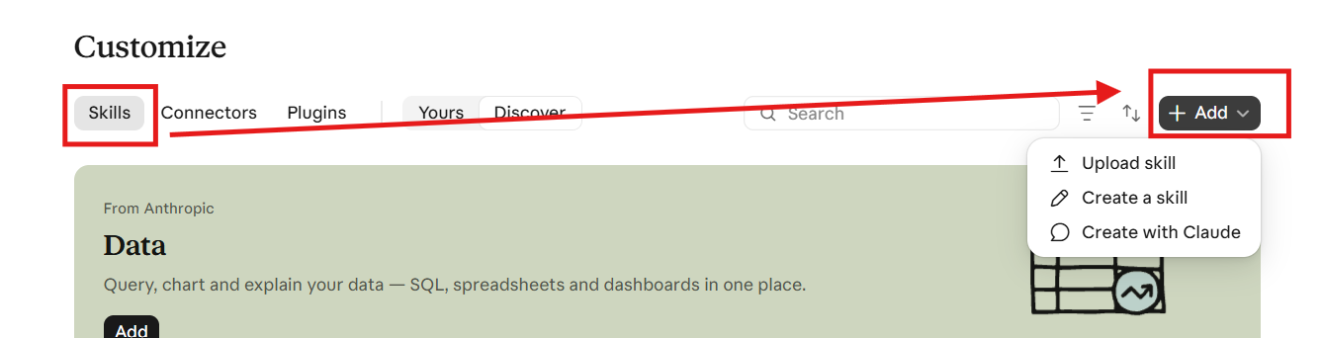
2. Select Add and choose Upload a skill.

Gemini
Web navigation: Open gemini.google.com. Expand the side menu and select Customize > Skills. If Customize is not visible, first select More.
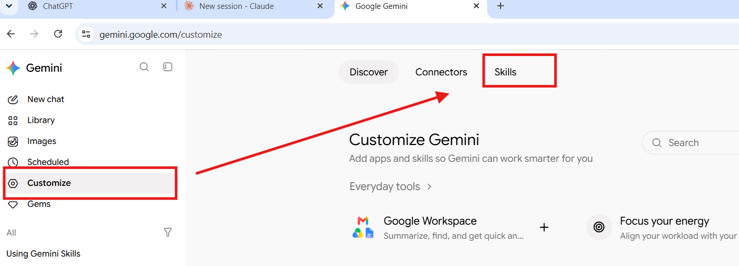
1. Navigate to Customize > Skills.
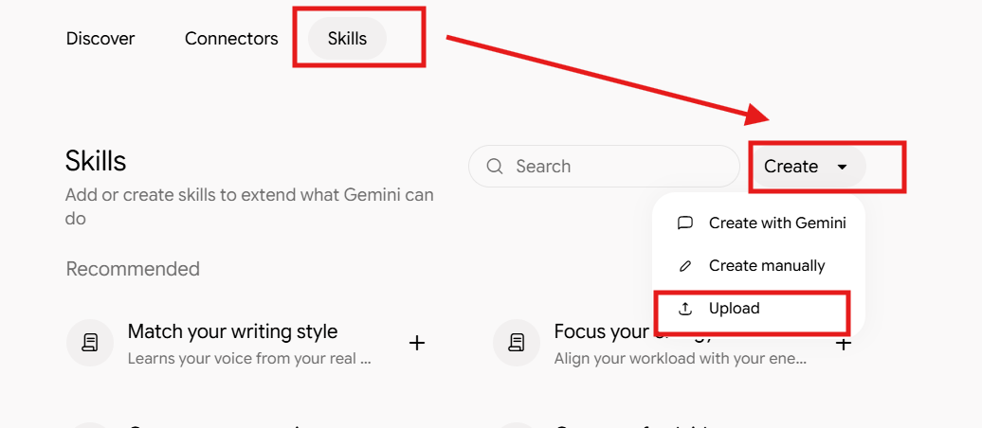
2. Select Create, then Upload.
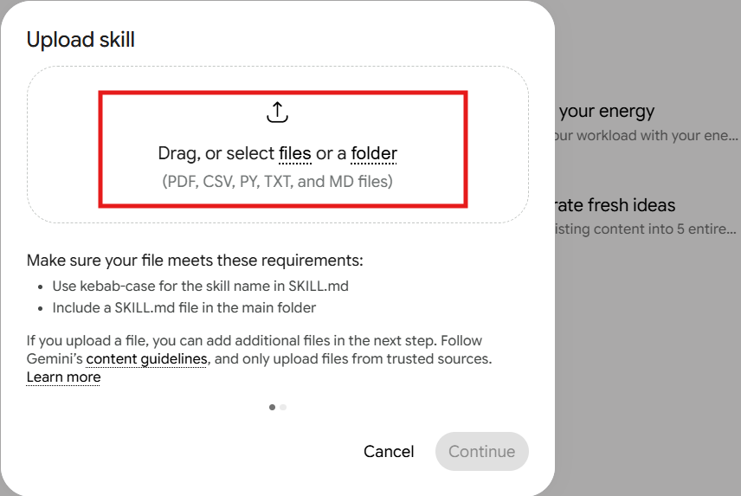
3. Select or drag the approved file or folder into the upload window.

After Uploading
☐ Confirm that the uploaded material is the correct source.
☐ Review the Skill’s purpose, trigger, steps, constraints, and expected output.
☐ Correct assumptions, overly broad instructions, or missing boundaries.
☐ Test with one routine prompt and one edge case.
☐ Revise and retest before sharing or using the Skill.
Remember: Uploading a useful reference file improves grounding, but the file does not replace clear instructions, testing, and human review.

Resources and References
The Complete Guide to Building Skills for Claude
How to Build a Skill in Gemini

Skill examples
Review examples to examine structure, scope, reusable instructions, and output patterns.
Repository of Skills
Skill – Causal Inference

Additional Workshop practice data
Use the public, deidentified sample material for the hands-on workshop exercise.
Medical Transcripts – Various specialties: MTSamples

Privacy and responsible use
Do not enter identifiable patient, student, employee, or institutional information into an unapproved AI platform. Follow applicable organizational policy and workshop guidance.

